BLG439E
Computer Project I
Project II

1) Huffman Encoding and Decoding

We used java.io and java.util libraries for java functions. In the android codes we used HuffmanCoding class for encoding and decoding the giving string.

We used priority queue for building the tree. Priority queue’s normal comparator is compare string values but we need to compare our nodes frequency therefore, we wrote our own comparator function in the our tree node class.

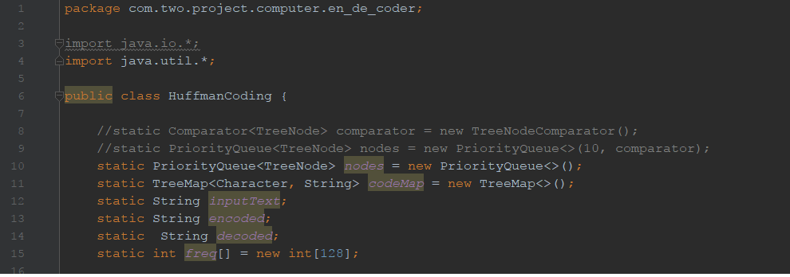
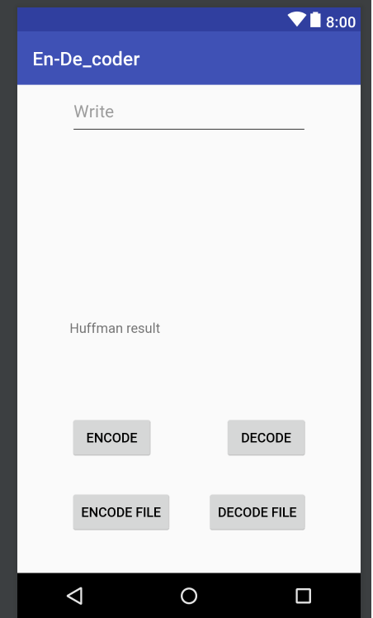
Pic1. Definitions

In the android application our main class is called MainActivity. It connected to the main_activity layout which is our programs main screen. In MainActivity class we called HCEncode and HCDecoder functions with input string. Input string can have 2 different values. One of them is the fileData which is the data inside the “input.txt” file inside the download folder. The other value for input string is users input text which is Pic 2. When user pushes the Encode button program sends the input with editText value and then encodes it. After encoding program shows the encoded result in the “Huffman result” area. When user pushes the Decode button program decodes it and shows the decoded result in the “Huffman result” area.

However when user pushes the Encode File or Decode File button program sends the inside of the file as a parameter of the HCEncode or HCDecode functions.

Pic2. Screen
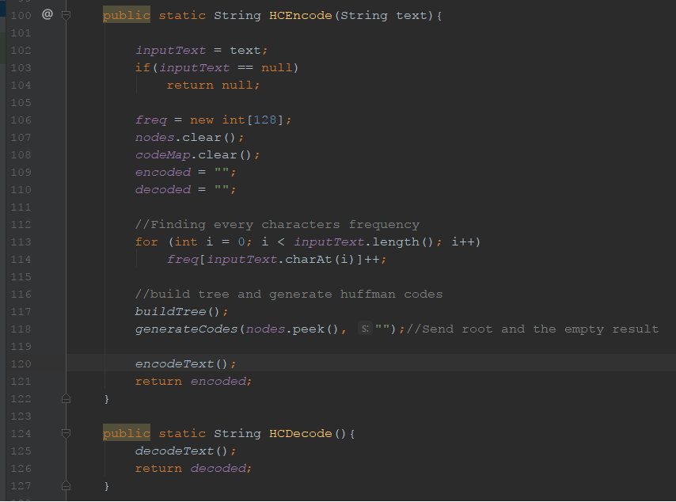
Pic3. HCEncode & HCDecode functions which are called from MainActivity

In the HCEncode, funciton first checks inside of the inputText for null values. Then creates new new frequency array, clears priority queue (nodes) and map (codeMap) and assigns empty strings to encoded and decoded strings for every new input values.

After that, for loop calculates the frequency of every character in the inputText and store them insedi the freq array. Then function calls buildTree, generateCodes, encodeText functions and returns encoded string value.

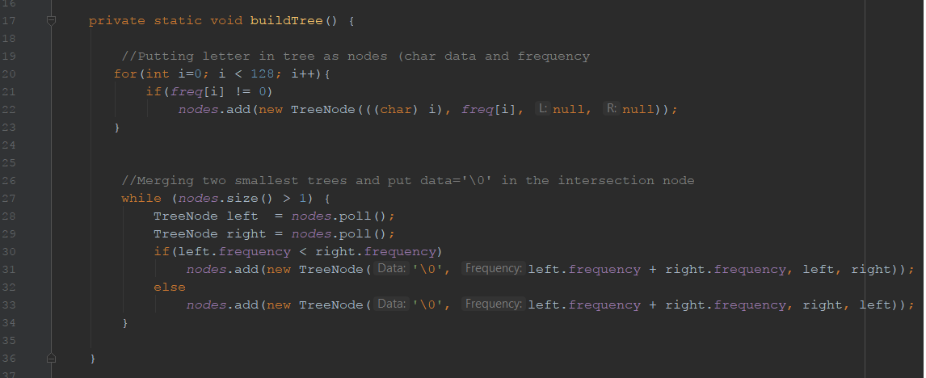
Pic4. buildTree funciton

In the buildTree, function first puts every non-zero frequency charater inside a prioirty queue. After adding every character inside a priority queue it merges smallest trees inside a while loop. Inside that loop first polls the head of queue as a left node and then polls the queue again as a right node. Compares the left and the right nodes frequency and if left one is already bigger than the right nodes frequency it merges them in the order and puts their merged nodes data end of file character (‘\0’). If their order is reverse they merge them with reverse order.

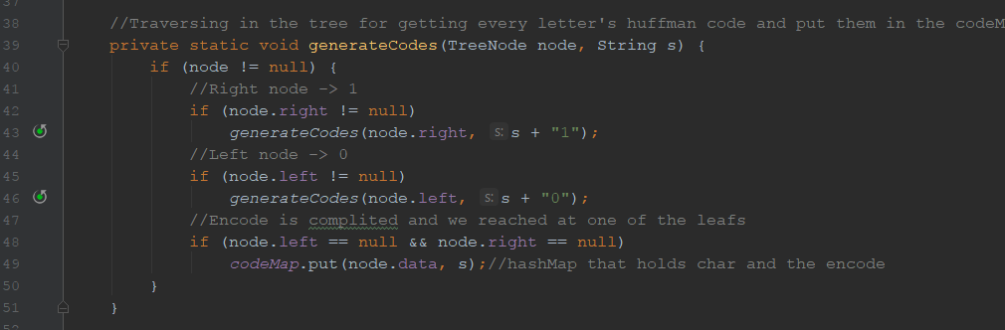
Pic5. GenerateCodes function

In the generateCodes, function generates Huffman codes with using tree. The function is recursive and traverse all over the tree with inorder traverse method. When traversing on the tree it checks every leaf for character and their huffman codes. They saves every character and their code inside the codeMap hash map.

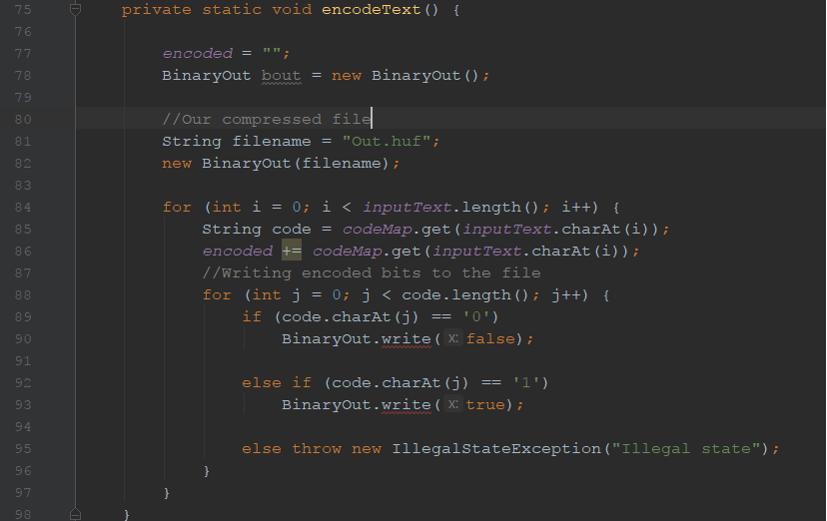
Pic6. EncodeText function

In the encodeText, function first clears the old encoded text then opens file with BinaryOut method which writes bits to the file. Later, it encodes file inside the for loop. It checks every character of inputText and finds every characters huffman code inside the codeMap. Finally, function write these bits to the file with BinaryOut.write function.

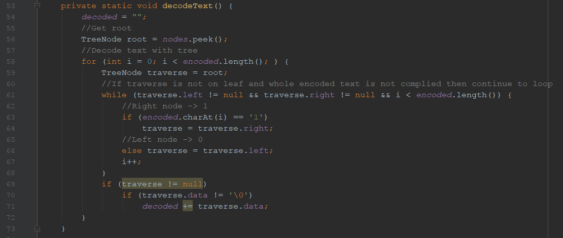
Pic7. DecodeText function

In the decodedText, function first clears the old decoded text then finds the root of the tree with peek function. After that, it traverses inside the encoded string at the same time it traverses inside the tree and finds the encoded character. When it reaches one of the leafs it stops and add that leafs character to the decoded strintg.

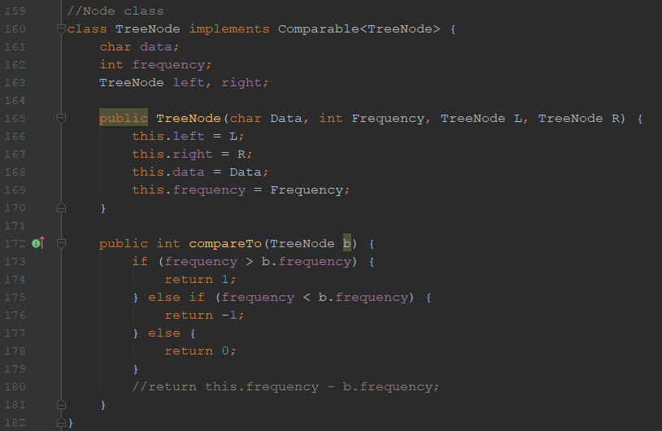
Pic8. TreeNode Class with compareTo funciton for priority queue

Tree Node class is the data structure for our tree. It contains char data, frequency of that data and 2 tree node pointers for leafs. Compare function is for priortiy queue. When priority queue wants to add new item to the queue it uses this function. We designed this function because standart compare function just compare string values while we need to compare our nodes frequency values.

We used BinaryOut and BinaryIn classes for writing and reading files with binary values. Therefore, we implement these functions inside our android application.

2) Connection

We used Bluetooth Chat Android Project for connection of android and pc. This project connect 2 devices via bluetooh sends strings. For our project we modified that Bluetooth Chat project and used it for our connection purpouses.

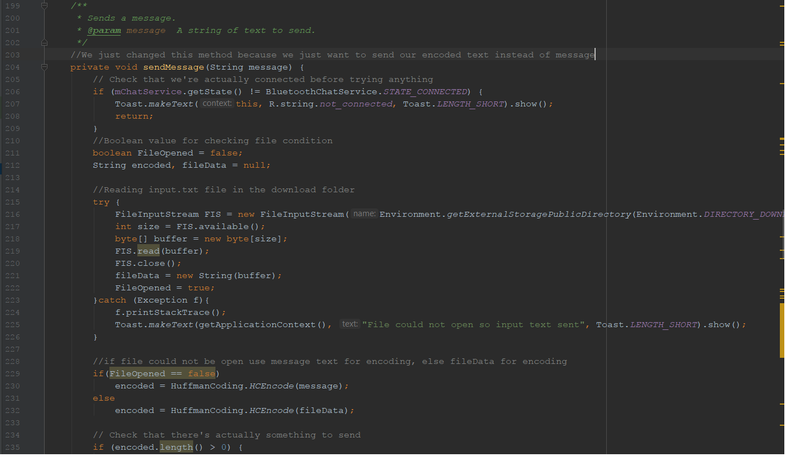
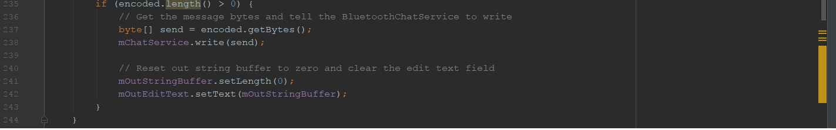
Pic9. Bluetooth Chat sendMessage function

We created 2 different android apps. One of them (Bluetooth Chat) can send encoded data via bluetooth but it cannot send huffman tree so decoding will not work on this app. Our second app (En/decoder) can encode and decode the text in the app but this app cannot send data to anywhere because, it does not have any connection part.

In the sendMessage, function first try to read the file which inside the downloads directory. If file could not be read then instead of fileData function uses users chat input for encoding. After encoded one of them it will send encoded data to the server pc and pc server can see this encoeded data on screen. However we could not manage to send tree for decoding so decoding part will not work properly. But decoding part’s code will correct and it will work on En/Decoder app.

Authers:
150130032 – Baran Kaya
150130047 – Kadir Enes Karslıoğlı
150140804 – Mehmet Ali Osman Atik

